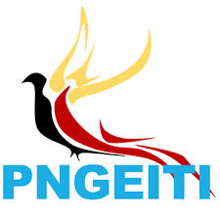
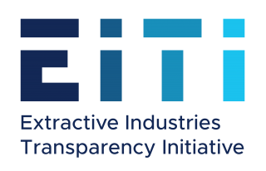
PNG EXTRACTIVE INDUSTRIES
TRANSPARENCY INITIATIVE
NATIONAL SECRETARIAT

October 14 2020

PRESS STATEMENT
Papua New Guinea is required to publicly disclose resource project agreements that are signed from year 2021 onwards

By the year 2021, Papua New Guinea as an EITI implementing country will be required to publicly disclose all mining, oil and gas project development agreements.
This is according to the Head of PNGEITI National Secretariat Mr. Lucas Alkan.
Mr. Alkan said that all project memorandum of agreements (MoAs) and contracts that will be entered into by the Government and Project developers as of next year 2021, will be required to be disclosed as public information.
“The current practice in Papua New Guinea is that once the agreements are signed, they are filed by the State Solicitor’s office and not disclosed as public information.
“A number of project agreements including that of the multi-billion Kina PNGLNG Project are protected by secrecy provisions and have not been disclosed for EITI reporting purposes,” Mr. Alkan said.
“These agreements needed to be disclosed, not only because PNG is implementing the EITI Global best practice standard but it is also in the best interest of the resource owners and the people of this country to know what is contained in these agreements.
Mr. Alkan added that mining and petroleum contracts, development licences and associated agreements are important fragments of the legal framework that governs the exploration and exploitation of our natural wealth.
“Disclosure of project agreements, MoAs and contracts, allows the public to monitor the conduct of the parties involved in the extraction and sale of mineral and petroleum commodities to determine who is accountable for non-compliance, whether it be benefits sharing, environmental impacts, social obligations and so forth.
“The government has been talking about getting its fair share from resource projects, however if the deals have been done badly in the first place by giving away too many fiscal concessions like a 10-year tax holiday or other tax exemptions then we have locked ourselves into a position where we cannot do much,” he said.
“If there are any legislative impediments to the disclosure of contracts and agreements, the laws must be reviewed as part of current legislative reforms in the extractive sector to amend these legislations that have prevented public disclosure of these important documents,” Mr. Alkan said.

ENDS////////

To know more, contact this number 313 3772 or email info@pngeiti.org.pg or visit the website www.pngeiti.org.pg The PNG Extractive Industries Transparency Initiative (PNGEITI) is an independent body established by the PNG Government to promote transparency and accountability of revenue it receives from the mining, oil & gas sectors and how it spends these funds. PNGEITI is part of a global best practice standard known as the Extractive Industries Transparency Initiative (EITI) that promotes good governance in the extractive sector. In EITI implementing countries, companies involved in the extractive natural wealth (oil, gas and minerals) industries are required to report on what they pay to the governments and governments are required to publish what they receive from these companies in a given financial year. These financial data are then reconciled by an independent administrator and are published in the annual EITI Reports for public information.

