Partnership to raise standards for PNG coconut export products
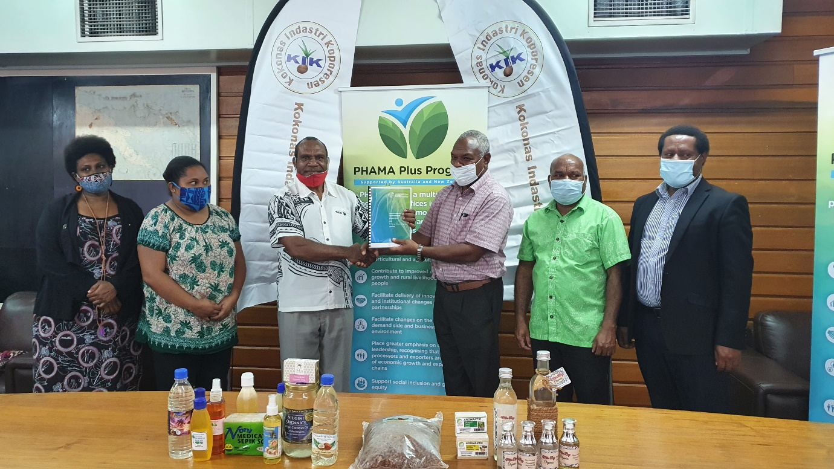
A new partnership between the Pacific Horticultural and Agricultural Market Access (PHAMA) Plus Program and the Kokonas Indastri Koporesen (KIK) will support the development of industry-wide standards for selected tradeable coconut products.

These industry standards will be developed and disseminated through the Australian and New Zealand governments funded PHAMA Plus program to processors, exporters and other interested stakeholders.

This will be done through a series of workshops in the major coconut-growing provinces of East New Britain, Madang and Milne Bay.

The demand for high-value coconut products in domestic and global markets has increased in recent years.

This has largely been driven by products which are now regarded as beneficial to health and wellness including body oils, lotions & creams, coconut soap, virgin coconut oil (VCO), coconut cooking oil, coconut water (processed & green tender nut), and coconut fibre products.

PHAMA Plus PNG Country Manager, Sidney Suma said the collaboration will boost the industry’s strategy of promoting high-value coconut products for both domestic and export markets while generating higher revenue for farmers and producers.

“A missing link is quality and compliance standards, which is an important component of the marketability of PNG high value coconut products. We’re pleased to work with KIK on making this possible for the industry as a whole,” Suma said.

In welcoming the partnership, KIK managing director Alan Aku said an important component of the partnership is to improve the support to women business owners and women participation.

“The coconut industry has the potential to contribute more to the value of the agricultural sector. In the coconut sector, women are the majority business owners and play a vital role in the value chain”, Aku said.

“Through this partnership, PHAMA Plus will support the inclusion of a Women’s Desk within the KIK office and facilitate Gender Equality, Disability Social Inclusion (GEDSI) training for field officers.”

“This will encourage women as well as youth and people living with disabilities’ participation in the various levels of the coconut supply/value chain,” added Aku.

PHAMA Plus support to the PNG coconut sector follows on from the Program’s work over the past three years with the KIK which included a Coconut Market Study and international food safety certification for PNG export business facilities to help access high value coconut export markets.

Coconut products are the fourth largest agricultural export commodity for PNG after cocoa, coffee and oil palm.

It generates export returns averaging K124 million annually (AU$79 million) and are an important contributor to the rural economy with over 460,000 households engaged in coconut activities, largely for cash cropping or own use.

ENDS
*For more information, please contact PHAMA Plus PNG Country Manager Sidney Suma on s.suma@phamaplus.com.au

