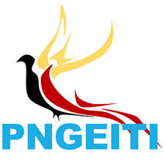
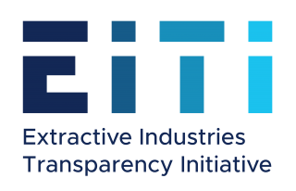
PNG EXTRACTIVE INDUSTRIES
TRANSPARENCY INITIATIVE
NATIONAL SECRETARIAT

November 03, 2020
PRESS STATEMENT
PNGEITI ensures EITI reporting clauses are included in the project agreement reviews
PNGEITI’s (PNG Extractive Industries Transparency Initiative) participation in the recent Project agreement reviews has paved an opportunity to advance the current scope of EITI mainstreaming from policy to practice.
The PNGEITI National Secretariat participated in the week-long review of Woodlark Mining Project MoA (Memorandum of Agreement) held in Alotau, Milne Bay, from October 12 to the 17, 2020.
Head of National Secretariat Mr. Lucas Alkan said the purpose of PNGEITI’s participation in the review of the Woodlark MoA was to ensure that the EITI provisions were included in the project agreement for contract transparency or disclosure of contracts that has now become mandatory for all EITI implementing countries including PNG.
“As part of its efforts to mainstream the EITI Standard and requirements on National and Subnational payments, including Beneficial Ownership, and Contract Transparency reporting, the Secretariat has been undertaking joint workshops, presentations and information sessions together with its Multi-Stakeholder Group (MSG) that comprises representatives from the Government, Extractive Industry and the Civil Society groups.
“On the last day of the forum, the State team included EITI reporting clause into the agreement. This is actually the second project MoA after K92 project to have an EITI Reporting clause included,” Mr. Alkan said.
“The PNGEITI envisage to cover all mining projects in the country to capture national and subnational reporting requirements,” Mr. Alkan added.
The forum discussed various undertakings by the MoA parties, of which some of the issues raised were relevant to EITI such as the need to;
- Create EITI awareness at the project impacted areas, especially the communities;
- Report royalty distribution in monetary value;
- Disclose in monetary value the Developer and State’s share of the total aggregate profit/return on the mine project;
- Disclose production volumes and values for gold extracted;
- Inform landowners well on the ownership of the infrastructure/services during operation of the mine before its closure;
- Disclose data on special support grant – this is in relation to custodians of mining trust accounts in terms of disclosure of trust account information relating to payments and recipients/expenditures; and.
- Create greater awareness on information relating to economic and social impact assessment report by the people of the impacted area.
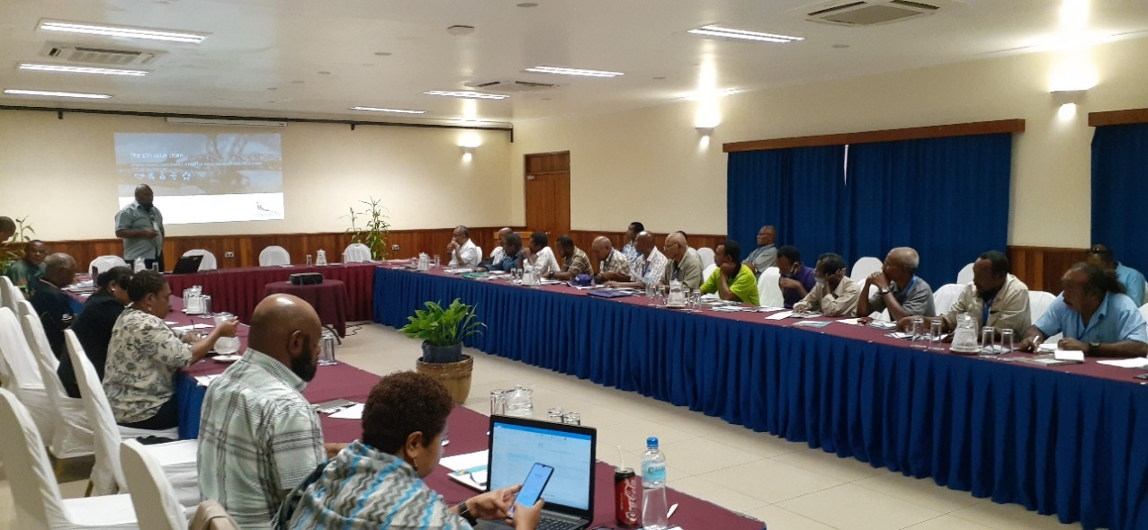
In front: Deputy Head of PNGEITI National Secretariat Christopher Tabel stressed on the importance of ensuring contract transparency and systematic reporting is built into transparency mechanisms in contracts and MoAs.

ENDS////////

To know more, contact this number 313 3772 or email info@pngeiti.org.pg or visit the website www.pngeiti.org.pg The PNG Extractive Industries Transparency Initiative (PNGEITI) is an independent body established by the PNG Government to promote transparency and accountability of revenue it receives from the mining, oil & gas sectors and how it spends these funds. PNGEITI is part of a global best practice standard known as the Extractive Industries Transparency Initiative (EITI) that promotes good governance in the extractive sector. In EITI implementing countries, companies involved in the extractive natural wealth (oil, gas and minerals) industries are required to report on what they pay to the governments and governments are required to publish what they receive from these companies in a given financial year. These financial data are then reconciled by an independent administrator and are published in the annual EITI Reports for public information.

