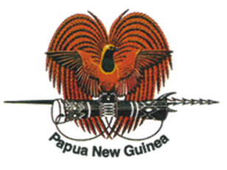
Expo2020 Secretariat MEDIA RELEASE
Department of Foreign Affairs
& International Trade

Embassy of Papua New Guinea Brussels Belgium

PAPUA NEW GUINEA TO PARTICIPATE IN EXPO 2020 DUBAI

Preparation for the World Expo 2020 in Dubai that was deferred to October 2021 due to the Covid-19 pandemic is progressing on target to start opening its doors for the world on 1st October this year.

Bureau International des Exposition (BIE) in Paris is responsible for organizing the World Expositions every four years.

Papua New Guinea’s participation in Expo2020 was approved by the National Executive Council upon invitation from the Ruler of Dubai and Deputy Prime Minister of the United Arab Emirates, Sheikh Mohammed bin Rashid Al Maktoum.

NEC also appointed Papua New Guinea’s Ambassador to Belgium and the European Union His Excellency Mr. Joshua Kalinoe as Commissioner General. Further, NEC approved the national participation and coordination structure, led by the Department of Foreign Affairs and International Trade and includes relevant agencies of Government.

The PNG private sector is represented by the PNG Manufacturing Council in the national coordination structure. The Council will be provided a space at the PNG Pavilion in Dubai to coordinate activities of the private sector, including having representation at the different pavilion and Exposition thematic events organized throughout the six months period.

The host, Dubai, one of the Emirates of the United Arab Emirates (UAE) has decided to make Expo2020 different from other past events. The focus is on partnership and development, sharing ideas, technology and innovation by bringing countries together in a globalising world.

Through the Dubai Expo2020 Organising Committee, the Government of UAE is meeting the Pavilion cost of small states, including that of Papua New Guinea. In addition, the Expo Organising Committee would pay for one 20ft container and the associated shipping and delivery cost from Port Moresby to Dubai and return for the display and commercial materials. However, PNG will pay import duty for commercial products.

Papua New Guinea’s pavilion is in the Sustainable thematic area of the Expo village and construction has been completed and interior design is being worked on. The Dubai Exposition Committee will also pay for the running of the pavilion, including maintenance and utility cost.

Papua New Guinea and the UAE formerly established diplomatic representation in 2018. Papua New Guinea’s Embassy in Brussels is accredited to the UAE while the UAE Embassy in Singapore is accredited to Papua New Guinea.

The PNG Expo 2020 coordinating team comprises representatives from relevant Government Departments and the PNG Manufacturers Council, representing the private sector.

The Expo2020 Dubai programme includes National Day celebration where each participating country is given a half-day time slot to show case its culture. PNG has secured a time slot for February 2022 and the national preparatory working group has tasked the National Cultural Commission to take a lead in the planning and execution of this event in consultation with the Expo2020 Events Team in Dubai.

The National Coordination Team led by the Department of Foreign Affairs and International Trade are putting final touches to the Participation Strategy which have a string of sectorial action plans before taking it to the Ministerial oversight Committee for endorsement and final clearance.

Further details of Papua New Guinea’s participation, including elements of the Participation Strategy and the pavilion design and content will be uploaded for public information once the appropriate platforms are constructed by the Department of Information, Communication and Technology (DCIT) who is the lead agency in telling the PNG story electronically, including through a 3D participative platform at the PNG pavilion in Dubai which will be made available for visitors to use.

Apart from showcasing PNG’s vast natural resources, diversified culture, and the unique flora and fauna, the PNG Expo2020 story will include the promotion and exposure of products from SMEs and the cottage industry, including artifacts, crafts, spices, coconut by-products and jewelry.

Ambassador Kalinoe who attended the final International Participants Meeting in Dubai on 4-5 May said the opening ceremony is on target for October and all the participants will be ready for opening their pavilions by then.

“The PNG Expo2020 team is stepping up its preparations with the mobilisation of display and commercial materials to be shipped by mid-June.

“I am appealing to all the stakeholders, including the Department of Treasury to immediately release the funds approved by the NEC for mobilisation so that artifacts and crafts both for display and sale as samples from the SMEs and cottage industry participants could be acquired.

“We must get the container which is paid for by the Government of UAE filled with the materials by end of May. Otherwise, the container will depart empty and PNG will have an empty pavilion with no story to tell, ” Ambassador Kalinoe said.
He said Expo2020 is a major international event that will bring over 190 countries together, large and small. PNG has a unique and exciting story to tell about its natural resource endowment, products, human capital, SME and cottage industry connectivity in the age of e-commerce.

Ambassador Kalinoe said the return on this investment in respect of stimulating domestic economic growth in the medium to long term is immeasurable.

“I am confident that the PNG Expo2020 team will bring several multi-million Kina investment projects and find more partners for trade, especially for our SMEs, cottage industry participants and the agriculture sector.

“Cross-border trade in products and services at all sectors of the economy is the major catalyst for creating lasting economic growth and its about time bureaucrats in Treasury and the PNG public service generally at the top management level realize this fact and facilitate its growth.

“ I am baffled to understand why the senior bureaucrats are so inward looking and do not see the opportunities in the international environment and think smart to capture these opportunities. And that means spending money to make money”, Ambassador Kalinoe said.

ENDS

Authorized for release to the Media by:

Joshua R. Kalinoe, CSM, CBE
Ambassador &
Commissioner General Expo2020
Embassy of Papua New Guinea
Brussels, Belgium

11th May 2021

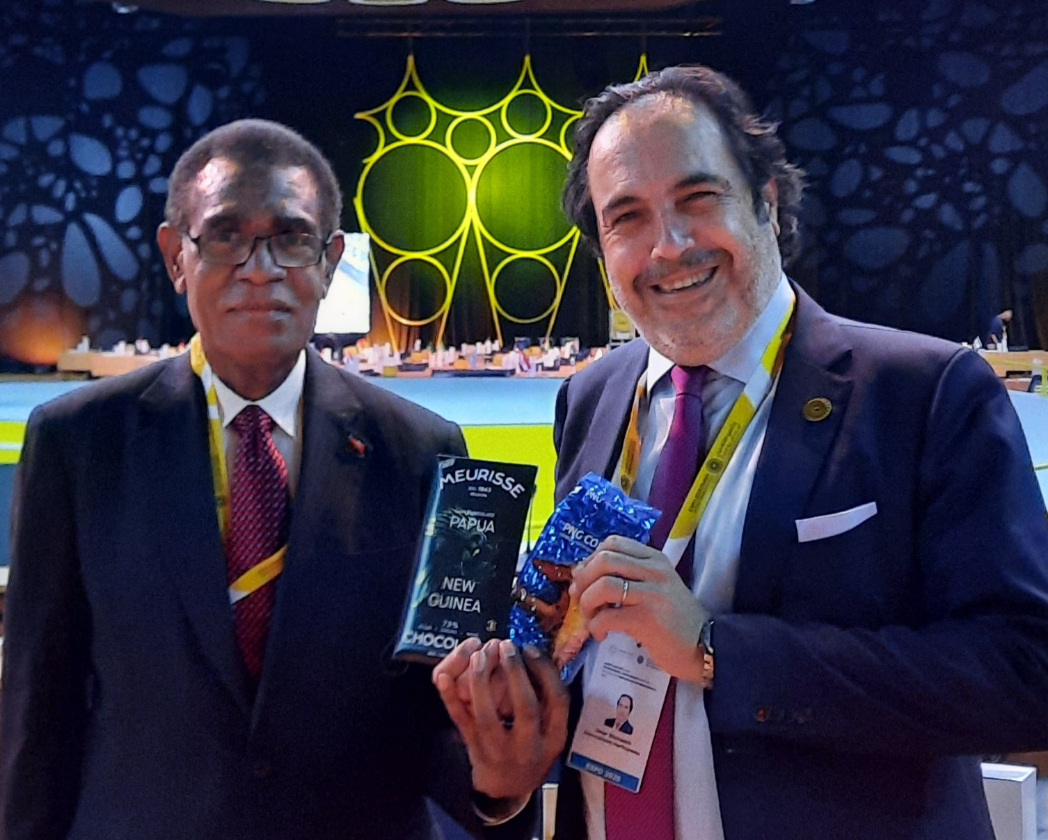

Ambassador Joshua Kalinoe (left) presents PNG Dark Chocolate produced by a Belgian Company and PNG Coffee Beans to the Chief of International Participants, Dr. Omar Shehadeh at the recently concluded IPM Meeting in Dubai.

