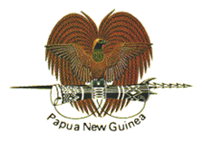
MEDIA RELEASE

EMBASSY OF PAPUA NEW GUINEA, BRUSSELS BELGIUM

Papua New Guinea signed the Multilateral Convention on Mutual Administrative Assistance with the Organization for Economic Co-operation and Development (OECD) in Paris, France, on 11 August 2021, joining 142 other countries, that include countries from the G20, OECD, and a growing list of developing countries from the Organization of African Caribbean and Pacific States (OACPS) Group.

Papua New Guinea Ambassador to the Kingdom of Belgium and EU with concurrent accreditation to the Republic of France, HE Joshua Kalinoe signed the Agreement on behalf of the State of Papua Guinea with delegated powers from the Minister for Foreign Affairs and in his capacity as Ambassador Extraordinary and Plenipotentiary.

Accession to the Convention means that Papua New Guinea will firstly open up its treaty network for the exchange of information for tax purposes, including on tax evasion and avoidance with signatory jurisdictions.

Secondly, this will facilitate and strengthen access to OECD led initiatives such as Tax Inspectors without Borders and other internationally accepted tax compliance and transparency standards.

In thanking the OECD for facilitating PNG's accession to the MAAC, Ambassador Kalinoe said that PNG has so far been compliant with the EU standards on tax compliance and money laundering and noted that the OECD could assist in working with the country's competent authorities to ensure that PNG continue to meet international standards, including those of the EU.

"It is my hope that PNG will work closely with the OECD to ensure that my country meets international financial accountability standards, including on tax compliance and money laundering," Ambassador Kalinoe said.

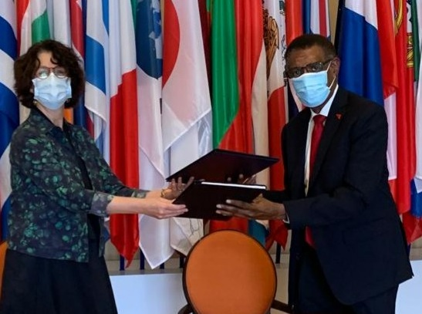

His Excellency Mr. Joshua Kalinoe, Papua New Guinea Ambassador to the Kingdom of Belgium and the EU with concurrent accreditation to the Republic of France (right) exchanges the signed Agreement with Josee Fecteau, Director for Legal Affairs of the OECD in Paris.

Authorised for Release
By Ambassador Joshua R Kalinoe, CSM CBE
Embassy of Papua New Guinea
Brussels
Kingdom of Belgium

_____________________________________________________________________
430 Avenue de Tervuren 1150 Brussels, Kingdom of Belgium, Tel: +32.2.779.0609, Fax: +32.2.772.7088, Email: kundu.brussels@skynet.be

